DBMS LAB

## DATA BASE MANAGEMENT SYSTEM

# ASSIGNMENT – 1

NAME – ROUNAK SAHA

ROLL NO:- 002211001132

CLASS - 2ND YEAR 1ST SEM

>>**CREATING TABLE FOR EMPLOYEES**

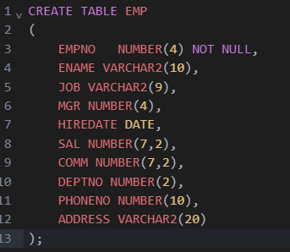

>> **INSERTING DATA**

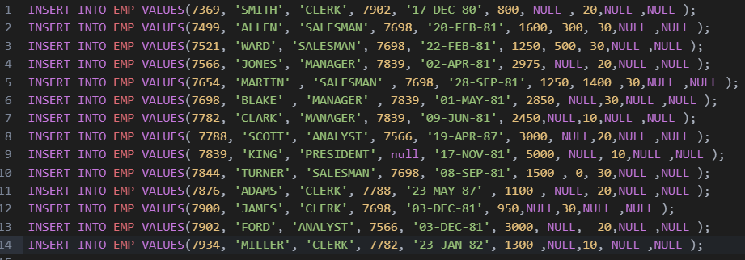

>>**CREATING TABLE FOR DEPARTMENT**

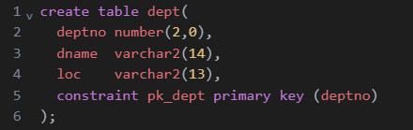

>>**INSERTING DATA**

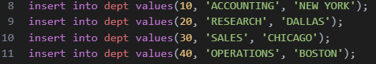

>>**CREATING TABLE FOR SALGRADE**

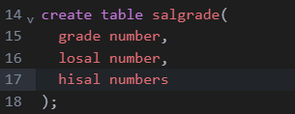

>>**INSERTING DATA**

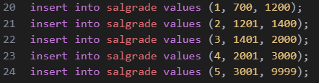

**1. Show the details of all employees.**



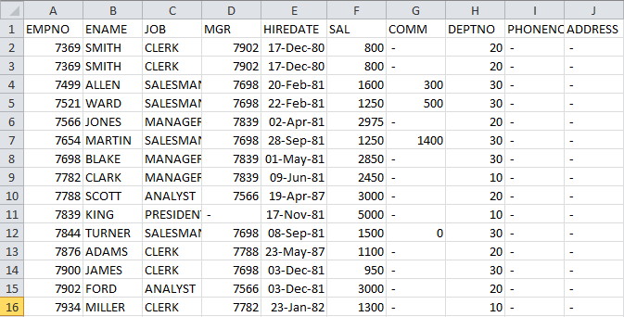

**2. Show the department no. and name of all departments.**



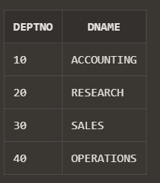

**3. Display the employee id, name and department no of all employees whose department no**

**is 20.**

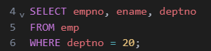

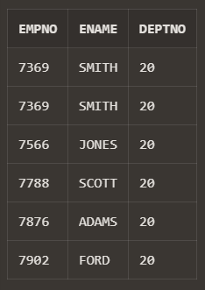

**4. Display the details of all employees where department no should be in descending order.**

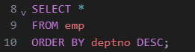

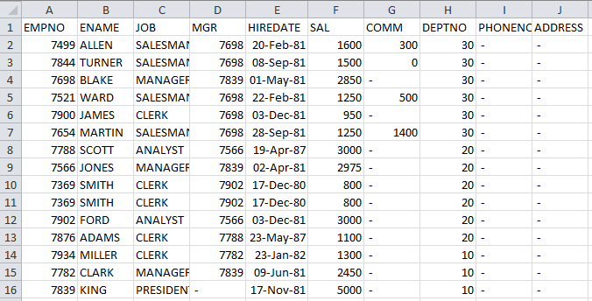

**5. Show all available jobs in the employee table.**



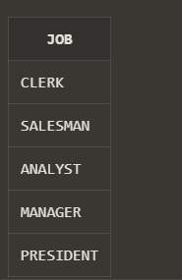

**6. Show the name, Annual Salary and department no of employees who works as a clerk in**

**department 20.**

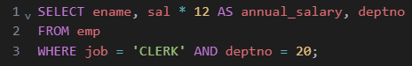

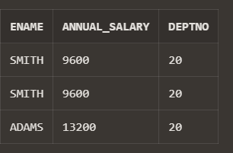

**7. Show the name and HIRED date of those employee whose name start with ‘S’ or second**

**character is ‘C’.**

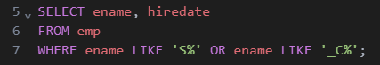

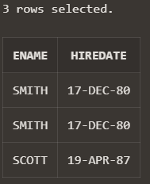

**8. Show the name, hire date and salary of those employee who are not a manager.**

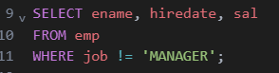

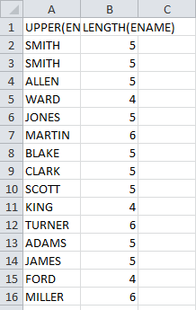

**9. Display all employee names in title case and length of the name.**





**10. Display the name of employee who gets the salary between 4000 to 6000.**

